Transition Rites
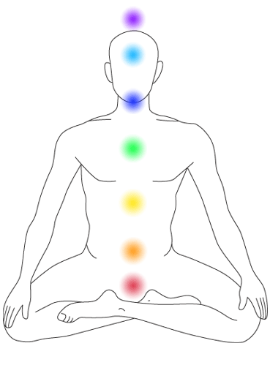
These ancient rites have been used by the shaman of Peru for many centuries. They have recently been shared with us in the West to help us recognise and nurture the major transitions in our lives, where we release the past to facilitate stepping into the new.
This letting go of the past is a key premise within these rites, that we cannot simply add on the new to the old, something has to ‘die’ to create the space for the new to come in. I believe we instinctively know this to be true, we see it in nature where the seasons show us the cycle of death and rebirth; we see it in ourselves through the female menstrual cycle. We even de-clutter our houses to create space for new energy to arrive.
The treatment you have just received honours this cycle. I have gathered from above your chakras the threads to the key structures in your life that held you in your past; your relationships, core beliefs, education, household situation, career, life events and traumas. By releasing these threads I could then lift off the old light body built from these experiences and send it back to Source. We then connected to the version of you from your future that is most actualised, most fulfilled, that most honours your soul’s journey in this body. The gifts that you brought in, combined with your pure essence held in your chakras, is now actively creating a new light body, the light body of the new you.
This ceremony has taken place at the energetic level. I strongly recommend that you now bring this into the physical. The more you honour and engage with this new version of you, the less you will be pulled back into previous habits and beliefs by the old structures of your life, and the people who do not yet know that you have changed, that the old you has literally died. New neural pathways can build over the weeks ahead to deeply embed these changes. Once your energy field has settled, life and the external world will inevitably change to reflect this, as above so below, as without, so within.
To embody this new energy, you could sit with the picture I have drawn for you above and feel the new essences in each chakra. You could create a new picture more personal to you, or find stones, plants or crystals that you can lay out in the garden to represent this new energy. Do whatever you are drawn to do to be with this new version of you in the physical realm. If you feel the energy slipping in any way, feel for the chakras that are most threatened by the old you, and reconnect with the gifts that lie in there and the pure essence of you that holds them. Most of all, please do see this as a joyful gift and enjoy the process!

